Images of June 2017 Cabin Wildlife at the Hedges on Blue Mtn. Lake, NY

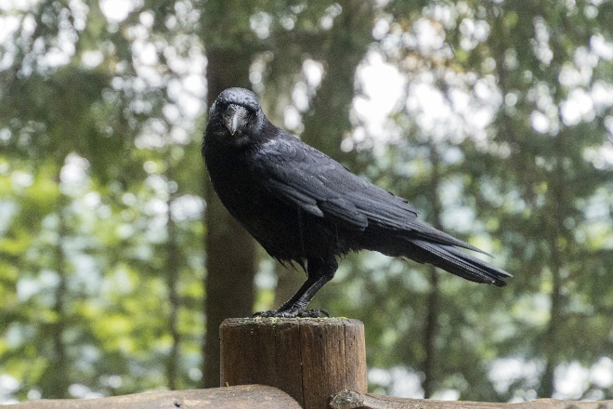This is a photo album of a raven and a squirrel who silently visited us during our stay at the Hedges on Blue Mtn. Lake, NY. Our daughter, Jennifer, and our two sons, Dave, and Steve, with their families joining us for an extended weekend. During our stay, we were continually visited by Edgar. To us, Edgar was so-named since he appeared to be a raven who silently ate our unsalted peanuts. He semed to attract a squirrel, nameless, who decided the “goodies” should be shared. A lot of activities resulting in a photo or two throughout the almost two weeks.

And for the photos, click [The Hedges Wildlife– June 2017](https://goo.gl/photos/VgPHJ8o7HBAjZrVe8).